21 February 2011

NEW PRODUCT ANNOUNCEMENT

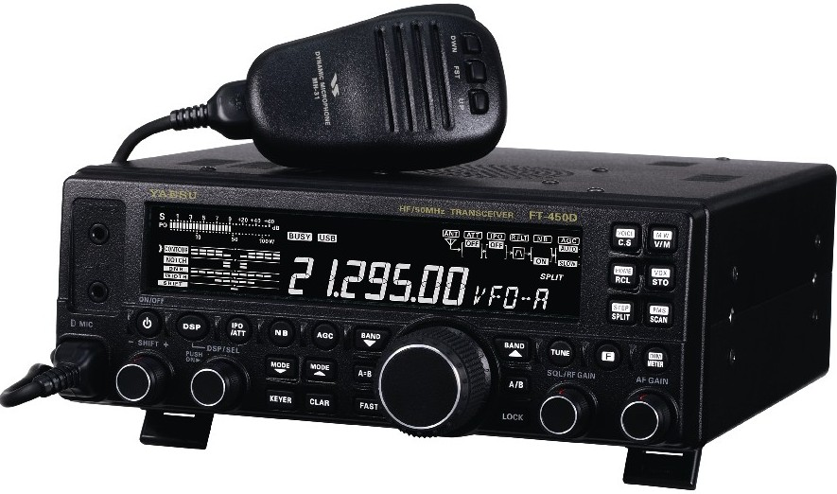

Re: FT-450D 100W HF/50MHz All Mode Transceiver (CE)
We proudly introduce the new 2nd generation FT-450D 100-Watt HF/50MHz transceiver, ultra compact HF Transceiver. The FT-450D follows on the success that the FT-450 achieved among Amateur Radio operators, from the newly licensed to the highly-motivated DX chaser.

The new FT-450D provides World Class performance in an easy to operate package. The performance remains at the same high level as the 1st generation AT model; a built-in ATU, 100 Watts of output power on SSB, CW and FM (25 Watts AM), with Digital Signal Processing (DSP) utilized throughout the design, providing leading-edge performance on both transmit and receive.

New additional features are:
- Key Illumination
- Foot Stand
- CW narrow 300 Hz IF DSP Filter available without any optional filters
- Classically Designed Main Dials and Knobs
- Striking new black and white look
- Supplied with the MH-31A8J hand microphone with up/down and fast keys and a tone selector switch.

Main Features

Built-in Antenna Tuning Unit
The FT-450D’s ATU (Automatic Antenna Tuner) includes 100 memories for quick tuning during field operation when using a folded dipole, etc.

Compact Size & Lightweight
The FT-450D is compact 9”W x 3.3”H x 8.5”D, lightweight 7.9 pounds package designed to be used as a desktop radio at home or in portable applications. The FT-450 can also be used mobile with the MMB-90 convenient mobile bracket accessory. Besides home or mobile operation, this easy to pack radio is a DXpeditioner or Emergency Service Provider’s dream come true - compact, lightweight, high performance receiver, and 100 watts on 160 through 6 meters.
Power Requirements
The FT-450 can be powered by any convenient 13.8 VDC 22 amp external power source.

Large Easy-to-Read LCD Display
You will love the FT-450 9-segment Black-Nega type LCD frequency display with larger-than-normal easy to read characters.

Built-in IF DSP
The legendary Yaesu IF DSP system, well regarded among top and world-class DX operators, is now available in an easy to operate package.

IF Roofing Filter
The FT-450 includes a 10 kHz bandwidth Roofing Filter in the 68 MHz first IF, right after the first mixer. This filter provides narrow-band selectivity to protect the following IF and DSP stages – a feature rarely found in rigs in this price range!

IF SHIFT & WIDTH
The FT-450 IF Width and IF Shift features are the primary tools you should use for best interference reduction.
The IF WIDTH tuning system allows you to vary the width of the DSP IF passband to eliminate interference. Moreover, the bandwidth may actually be expanded from its default setting, should you wish to enhance incoming signal fidelity when interference on the band is low. The IF WIDTH is varied in steps: SSB - 1.8/2.4/3.0 kHz. AM - 3.0/6.0/9.0 kHz. FM - 2.5/5.0. CW - 0.3/0.5/2.4 kHz.
The IF SHIFT tuning system allows you to vary the DSP filter passband higher or lower, without changing the pitch of the incoming Signal to reduce or eliminate interference. Because the carrier tuning frequency is not varied, there is no need to re-tune the operating frequency when eliminating the interference. The total passband tuning range for the IF Shift system is ±1 kHz. Rotate the [SHIFT] knob to the left or right to reduce the interference. You may observe the position of the passband in the “SHIFT” indicator of the DSP Graphic Display portion of the LCD front panel main display.

CONTOUR
The Contour filtering system provides a gentle shaping of the IF filter pass band to suppress or enhance particular frequency components, thus improving the sound and/or readability of a received signal. The DSP Contour filter is a unique capability of the receiver, providing either Nulling or Peaking of tuneable segments of the receiver passband to suppress interference or excessive frequency components on an incoming signal, or to peak those tuneable frequency segments. The amount of Nulling / Peaking and the bandwidth over which it is applied are adjustable via the Menu. The peak position of the contour filter is graphically depicted in the “CONTOUR” indicator of the DSP Graphic Display portion of the LCD front panel main display. SPECIAL FILTERING NOTE: The steep slopes of the DSP filtering can, when adjusted aggressively, impart an unnatural sound to an incoming signal. Often, a narrow bandwidth is not the key to improving copy. The incoming signal itself may have undesirable or excessive frequency components. By judicious use of the Contour filter, the “shoulder” of the passband response may be altered, or components removed from within the passband, allowing the desired signal to rise above the background noise and interference in a manner not obtainable with other filtering systems.

IF NOTCH
The IF Notch filter is a highly effective system that allows you to slice out an interfering beat note or other carrier signal from inside the receiver passband. You may observe the graphically depicted peak position of the IF Notch filter in the “NOTCH” indicator of the DSP Graphic Display portion of the LCD front panel main display.

DNR - Digital Noise Reduction
The Digital Noise Reduction (DNR) feature utilizes eleven (11) different mathematical algorithms to analyse and suppress different noise profiles encountered on the HF/50 MHz bands. You get to choose the selection that provides the best noise suppression. The DSP’s Digital Noise Reduction (DNR) system is designed to reduce the level of random noise found on the HF and 50 MHz bands. It is especially effective during SSB operation. Any of eleven different noise-reduction algorithms can be selected. Each of these algorithms was created for dealing with a different noise profile. You will want to experiment with the DNR system to find the best setting according to the noise currently being experienced that concurrently will allow the signal to rise up out of the noise.
Manual Notch Filter
The FT-450 Manual Notch Filter is a highly-effective system that slices out an interfering beat tone/signal.

IPO/ 20 dB ATT built-in
The received signal is reduced by 20 dB, and the incoming signal bypasses the RF preamplifier, yielding a direct feed to the first mixer.

CLARIFIER adjustment
You may change the receiving frequency only without changing the transmit frequency

QUICK SPLIT automatically set higher than the Main Frequency
The Quick Split feature allows you to set a one-touch offset of +5 kHz to be applied to your radio’s
transmit frequency compared to the receiving frequency. Furthermore, the transmit mode sets to the
same mode as the receiving frequency register.

TXW feature to monitor the xmit frequency when split
Monitor the transmit frequency when Split Frequency operation is engaged.

Digital Microphone Equalizer
Custom set your rig to match your voice characteristics for maximum power punch on the band.

CW Features:
• Built-In Electronic Keyer
Speed adjustable between 4 WPM and 60 WPM.
• Memory Keyer
CW messages can be saved in 3 memory banks.
• Spotting (Zero-Beating) CW Training Feature
Sends random Morse Code five-character groups via the sidetone.
• Beacon Function (up to 118 characters)
Up to 118 characters using the CW message keyer.

Rugged die-cast aluminium chassis
The rugged aluminium die-cast chassis with large cooling fan is made for your heavy-duty, extended high power operation.

Thermostatically controlled cooling fan
A large (70 x 70mm) quiet thermostatically controlled cooling fan is a solid foundation of the power amplifier during long hours of field use or home contesting operation.

Dedicated Data Jack for FSK-RTTY operation
The 6-pin input/output jack provides receiver audio and squelch signals, and accepts transmit (FSK/AFSK) audio and PTT control, from an external packet TNC.

CAT System (D-sub 9 pin): Computer programming
This 9-pin serial DB-9 jack allows external computer control of the FT-450D. Connect a (straight) serial cable from the CAT jack to the RS-232C COM port on your personal computer (no external interface is required).

Versatile Memory System
Each memory channel stores various settings, in addition to the frequency and mode.
• 500 memory channels with 13 Memory Groups
The FT-450D contains 500 regular memories that can be arranged in up to 10 separate groups, if desired.

My Band / My Mode function to recall personal favourites
The “My Bands” feature allows you to select several Amateur bands, and make only those bands available for Selection; The “My Modes” feature allows you to select the operating modes you wish to have available for selection.

CTCSS Operation (FM)
The FT-450D may be operated on 29 MHz and 50 MHz repeaters.

Important Feature for Visually Impaired Operators
You may confirm the current operating frequency (with resolution to the displayed 100 Hz digit), operating mode, and S-meter reading through the digital voice message announcement system.

Specifications
GENERAL
Rx Frequency Range | 30kHz - 56 MHz (operating)
 | 160 - 6 m (specified performance, Amateur Bands only)
TX Frequency Ranges | 160 - 6 m (Amateur Bands only)
Frequency Stability | ± 1 ppm/hour (@ +25ºC, after warmup)
Operating Temperature Range | -10ºC - +50ºC
Emission Mode | A1A (CW), A3E (AM), J3E (LSB,USB), F3E (FM)
Frequency Steps | 1/10/20Hz (SSB & CW), 100/200Hz (AM & FM)
Antenna Impedance | 50Ω, unbalanced
Power Consumption | RX (signal present) 1.5A
 | TX (100W) 22A
Supply Voltage | 13.8VDC, ±10%
Dimensions (W x H x D, mm) | 229 x 84 x 217
Weight (approx, kg) | 4.0
TRANSMITTER
Power Output | 100 Watts (25 Watts AM)
Modulation Types | J3E (SSB): Balanced
 | A3E (AM): Low-Level (Early Stage)
 | F3E (FM): Variable Reactance
Max FM Deviation | ±5.0kHz / ±2.5kHz
Harmonic Radiation | Better than -60dB (160 - 10 m Amateur bands)
 | Better than -70dB (6 m Amateur band)
SSB Carrier Suppression | At least 60dB below peak output
Undesired Sideband Suppression | At least 60dB below peak output
Audio Response (SSB) | Not more than -6dB from 300 to 2400Hz
Microphone Impedance | 600Ω (200 - 10 kΩ)
RECEIVER
Circuit Type | Double-Conversion superheterodyne
Intermediate Frequencies | 1st IF: 67.899MHz / 2nd IF: 24kHz
Sensitivity (IPO: “Off”, ATT: “Off”) | SSB (BW: 2.4kHz, 10dB S+N/N)
 | 0.25µV (1.8 - 2.0MHz)
 | 0.25µV (3.5 - 30MHz)
 | 0.20µV (50 - 54MHz)
 | AM (BW: 6kHz, 10dB S+N/N, 30% modulation @ 400Hz)
 | 2.00µV (1.8 - 2.0MHz)
 | 2.00µV (3.5 - 30 MHz)
 | 1.00µV (50 - 54MHz)
 | FM (BW: 15kHz, 12dB SINAD)
 | 0.50µV (28 - 30MHz)
0.30µV (50 - 54MHz)
There is no specification in frequency ranges not listed.
Squelch Sensitivity | SSB / CW / AM
(IPO: “Off”, ATT: “Off”) | 2.50µV (1.8 - 30MHz)
 | 1.00µV (50 - 54MHz)
 | FM
 | 0.32µV (28 - 30MHz)
0.16µV (50 - 54MHz)
There is no specification in frequency ranges not listed.
Selectivity | MODE | -6dB | -60dB
Selectivity | CW-N | 0.25kHz or better | 0.7kHz or less
Selectivity | SSB | 2.2kHz or better | 4.5kHz or less
Selectivity | AM | 6kHz or better | 20kHz or less
Selectivity | FM | 15kHz or better | 30kHz or less
Selectivity | FM-N | 9kHz or better | 25kHz or less
Image Rejection | 80dB or better
IF Rejection | 80dB or better (160 - 10m Amateur bands)
 | 65dB or better (6m Amateur band)
Maximum Audio Output | 2.2W into 4Ω with 10% THD
Audio Output Impedance | 4 to 16Ω (8Ω: Nominal)
Conducted Radiation | Less than 4000µµW
Note:
Specifications are subject to change, in the interest of technical improvement, without notice or obligation, and are guaranteed only within the amateur bands.

Accessories and Options

Part No. | Description
MD-200A8X | Elite Desktop Microphone
MD-100A8X | Desktop Microphone
MH-31A8J | Hand Microphone
MH-36E8J | DTMF Hand Microphone
YH-77STA | Lightweight Stereo Headphones
FP-1030A | External Power Supply
MMB-90 | Mobile Bracket
MHG-1 | Carrying Handle
Quadra System | Amplifier & Power Supply
CT-118 | Band Data Cable (Linear to FT-450D)
FC-40 | External Automatic Antenna Tuner  (for long wire antennas or long whip)
ATAS-120A | Active Tuning Antenna System
ATBK-100 | Base Kit for ATAS-120A
CT-39A | Packet Cable

